**Embedded Systems Spring 2019**

**Lab 1**

**Jonathan Colella**

**February 28, 2019**

**Purpose**

This lab introduces counters and debouncers in the context of VHDL modelling. I will create models for the various required components, then combine them into a single unit. The lab assignment will help develop my thinking when writing VHDL, and to gain experience in designing embedded systems. This will help serve as a foundation for later labs in this course.

**1a) Clock Divider**

**Theory of Operation**

This device takes in a 125MHz clock signal and outputs a 2Hz clock signal. It operates by counting every time a clock is input, and only outputs a clocked ‘1’ once for every 62,500,000 input clocks. It resets the counter each time this happens.

**Elaboration Schematic**

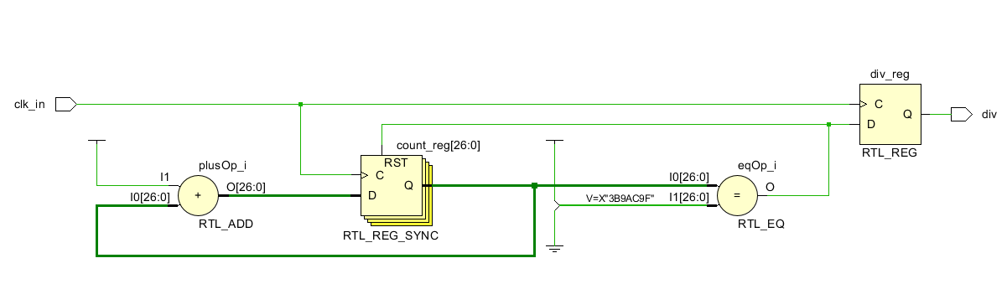

**Design**

library IEEE;

use IEEE.STD_LOGIC_1164.ALL;

use IEEE.STD_LOGIC_UNSIGNED.ALL; --this library makes incrementing the vector easier

entity clock_div is

Port ( clk_in : in STD_LOGIC;

div : out STD_LOGIC);

end clock_div;

--divides a 125MHZ signal down to a 2Hz signal

architecture Behavioral of clock_div is

signal count: std_logic_vector (26 downto 0); --26 bits needed to count to 62,499,999

begin

process(clk_in) begin

if (rising_edge(clk_in)) then

if (count = "11101110011010110010011111") then --binary for 62,499,999

count <= (others => '0'); --reset to 0 when we get to 62.5 million

div <= '1'; --output is high

else

count <= count + 1; --increment by one otherwise with help of unsigned

div <= '0'; --output is low

end if;

end if;

end process;

end Behavioral;

**Test Bench**

library IEEE;

use IEEE.STD_LOGIC_1164.ALL;

entity clock_div_tb is

end clock_div_tb;

architecture tb of clock_div_tb is

component clock_div

port ( clk_in : in std_logic;

div : out std_logic);

end component;

signal tb_clk : std_logic := '0';

signal tb_div : std_logic := '0';

begin

dut: clock_div port map (clk_in => tb_clk, div => tb_div);

process begin

tb_clk <= '0'; --simulate 125MHz clock

wait for 4 ns;

tb_clk <= '1';

wait for 4 ns;

end process;

end tb;

**Simulation**



The output oscillates at 2Hz.

**1b) Top-Level Divider**

**Theory of Operation**

This device is the top-level RTL schematic for the clock divider. It divides the clock down to 2 Hz and stores the current clock value in a register. This register allows the clock value to be held at either 1 or 0 as needed, as opposed to the clock_div module that only generates pulses.

**Elaboration Schematic**

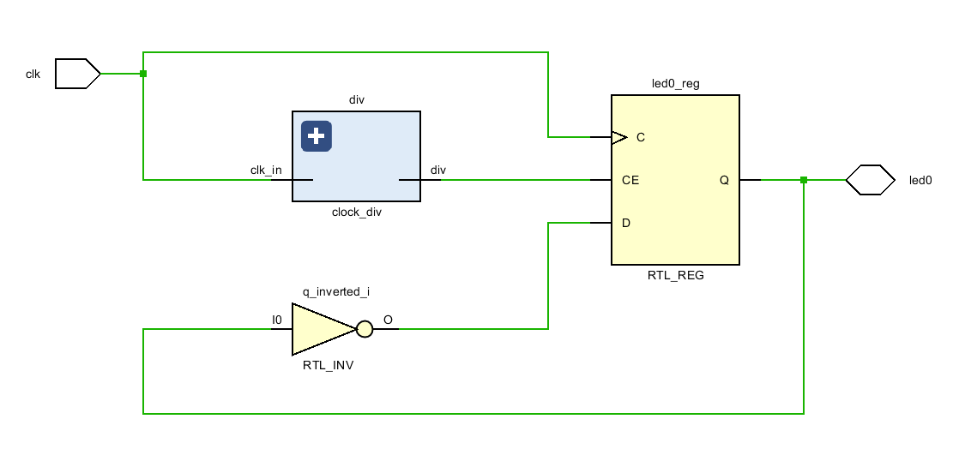

**Design**

library IEEE;

use IEEE.STD_LOGIC_1164.ALL;

entity divider_top is

Port ( clk : in STD_LOGIC;

led0 : inout STD_LOGIC);

end divider_top;

architecture rtl_ckt of divider_top is

--components

component clock_div

port(clk_in : in std_logic;

div : out std_logic);

end component;

--signals

signal div_output : std_logic;

signal q_inverted : std_logic;

Begin

div: clock_div

port map ( clk_in => clk,

div => div_output);

led_reg: process(clk)

Begin

if (rising_edge(clk)) then

if (div_output = '1') then

led0 <= q_inverted;

end if;

end if;

end process;

q_inverted <= NOT(led0);

end rtl_ckt;

**Discussion**

**1.1**

**1.2**

**2.1**

**2.2**

**2.3**

**2.4**